Design

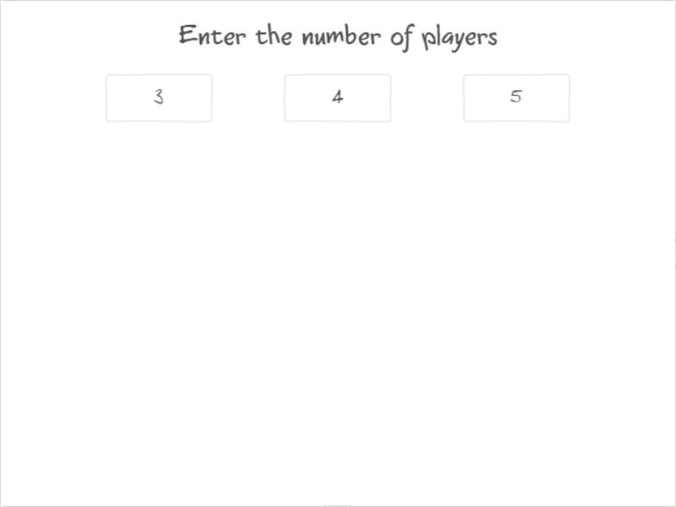

The initial screen let us to pick the number of players in a game

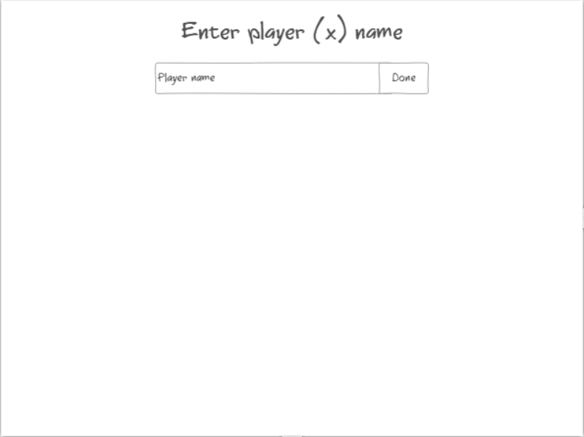

Screen to enter a player name, does not accept empty input.

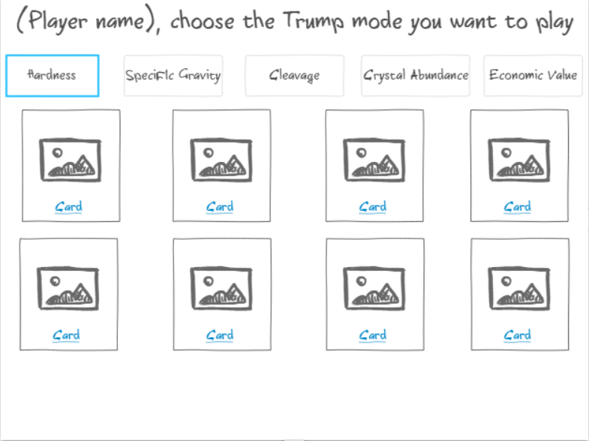

The initial screen of a game or when all but a player passed the turn that makes player to choose a trump category of a card.

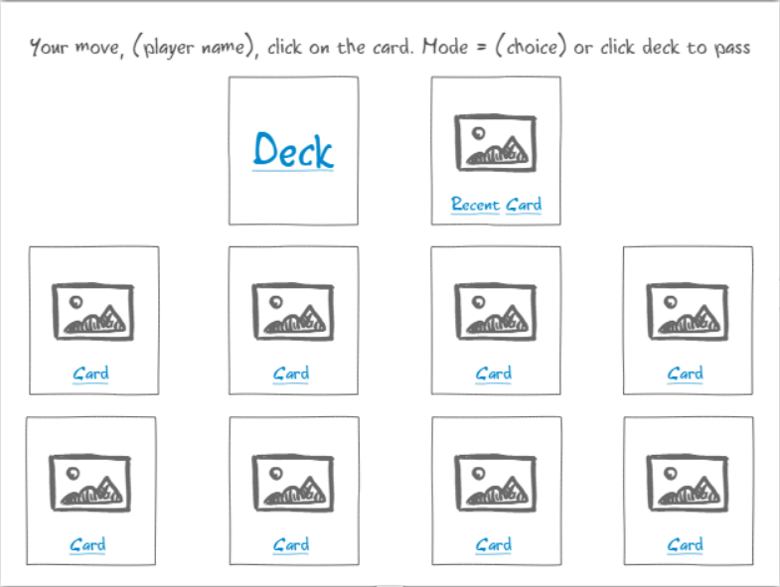

The screen when players can play the card or just pass the turn when they feel like they cannot outplay the recent card.

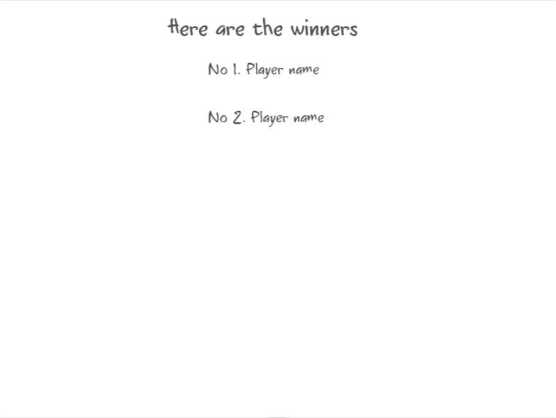

The last screen that shows the winners list (all players but the last player standing in a game).

Testing

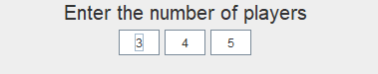

The first menu consists of how many number of players does the game has



After selecting the number of players, the player has to input each of the players’ name. In this menu, the empty input of players’ name brings loop to the menu that consists of input of each of the players’ name.

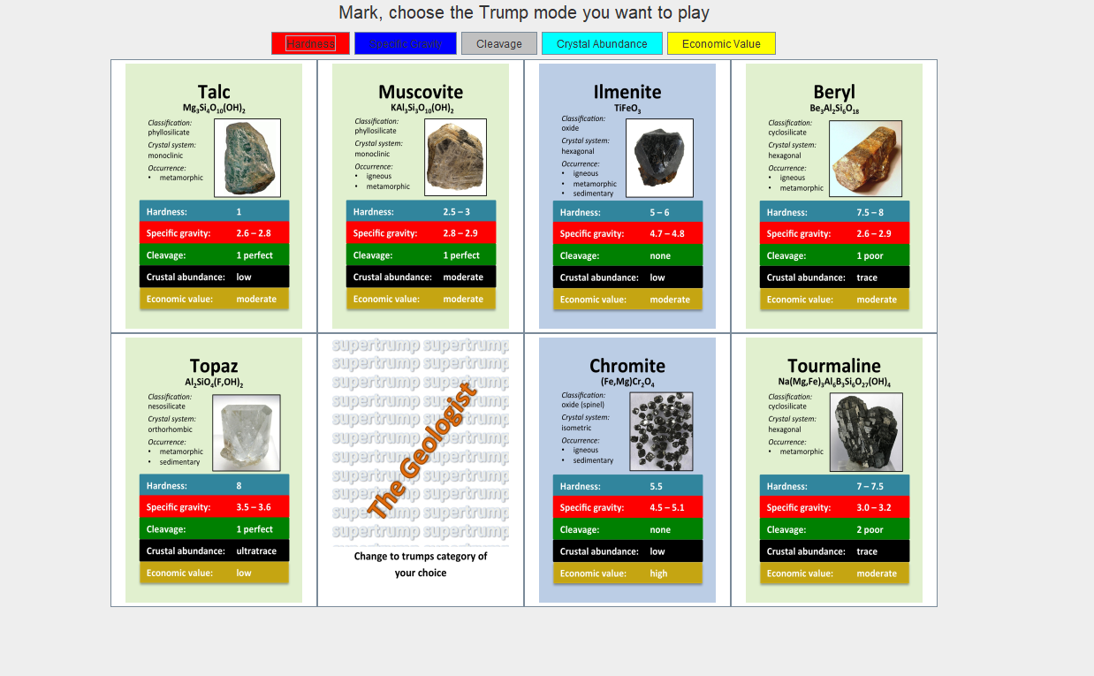

After entering the players’ name for the number of players, the first player can choose the trump category, which can be overwritten by when a specific Supertrumps card is played or all other players but him passed. This menu can only pick the trump category that cause the player to be unable to pick the card.

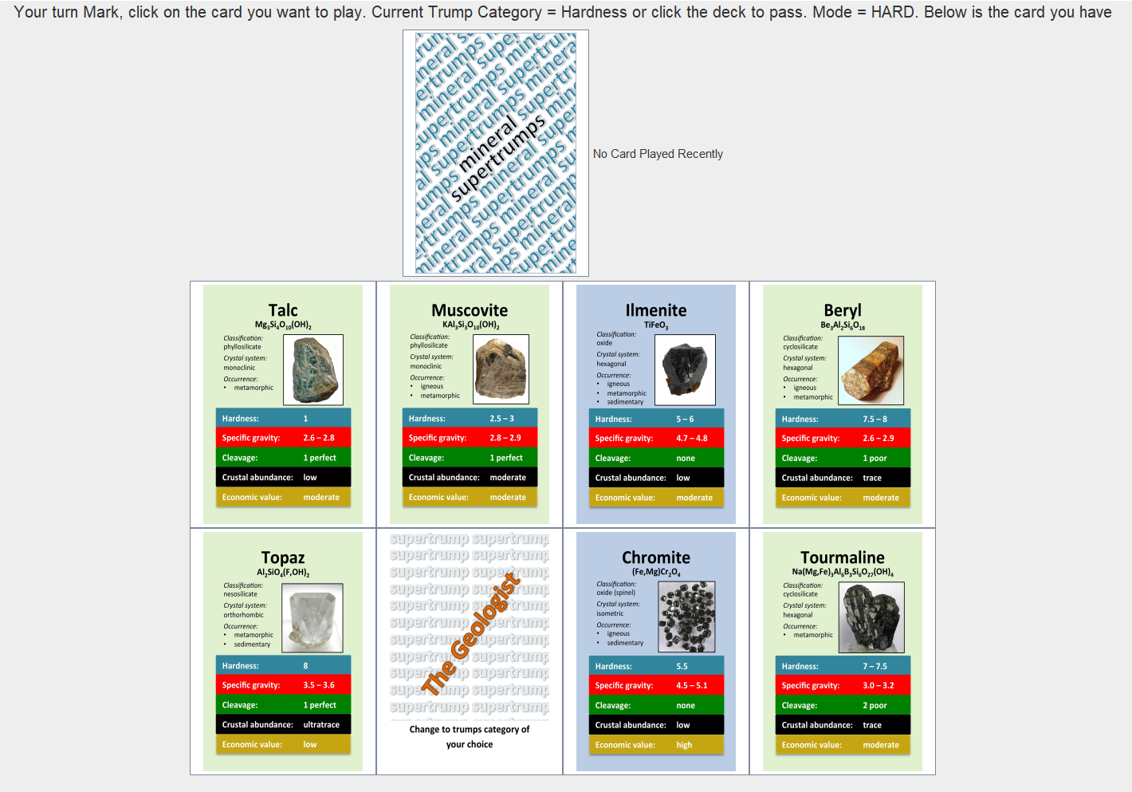

After choosing the desired trump mode, the first player can play the card and possible to click the deck to pass the turn although the player have cards to play.

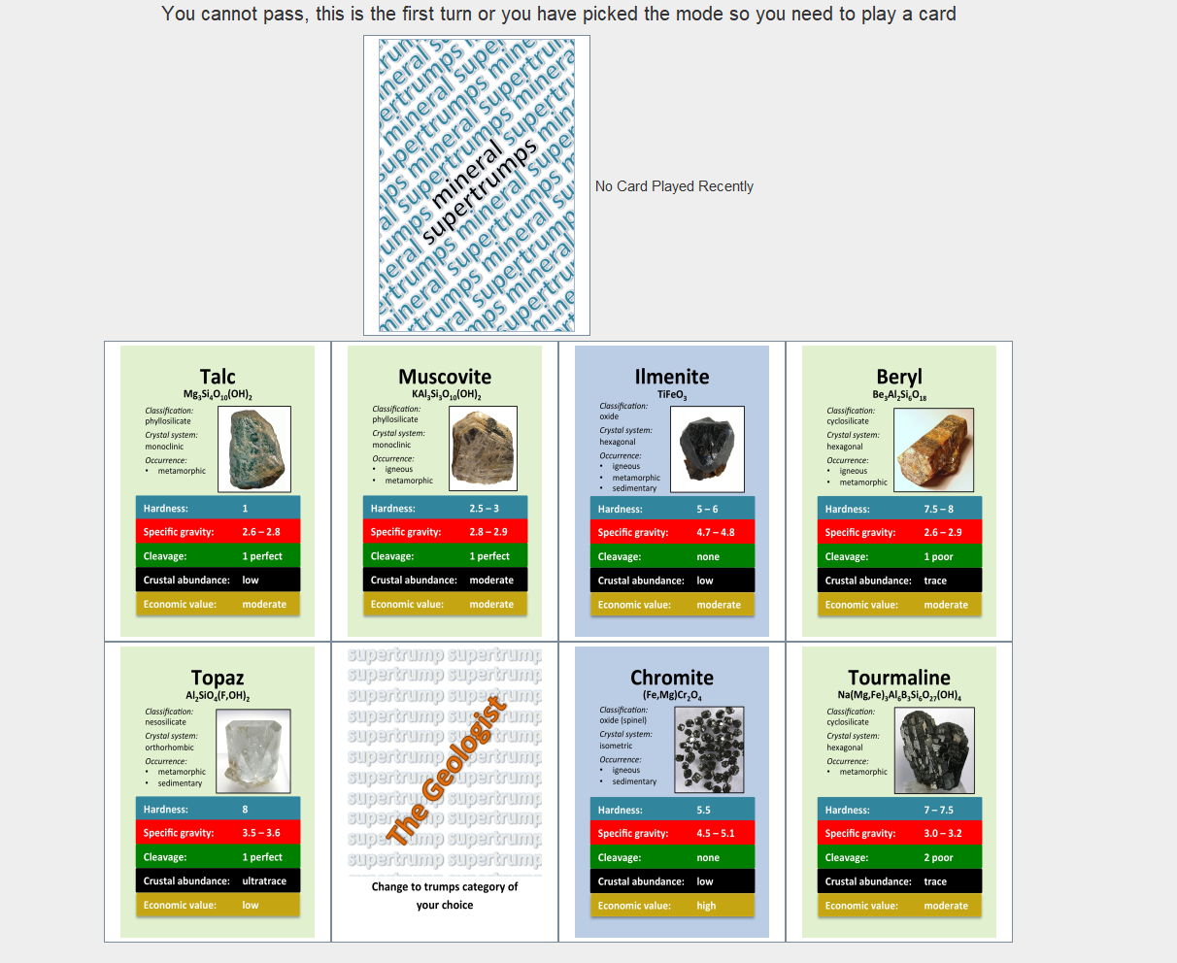

The player cannot pass the card when it is the first turn or the player just pick or change a supertrump mode.

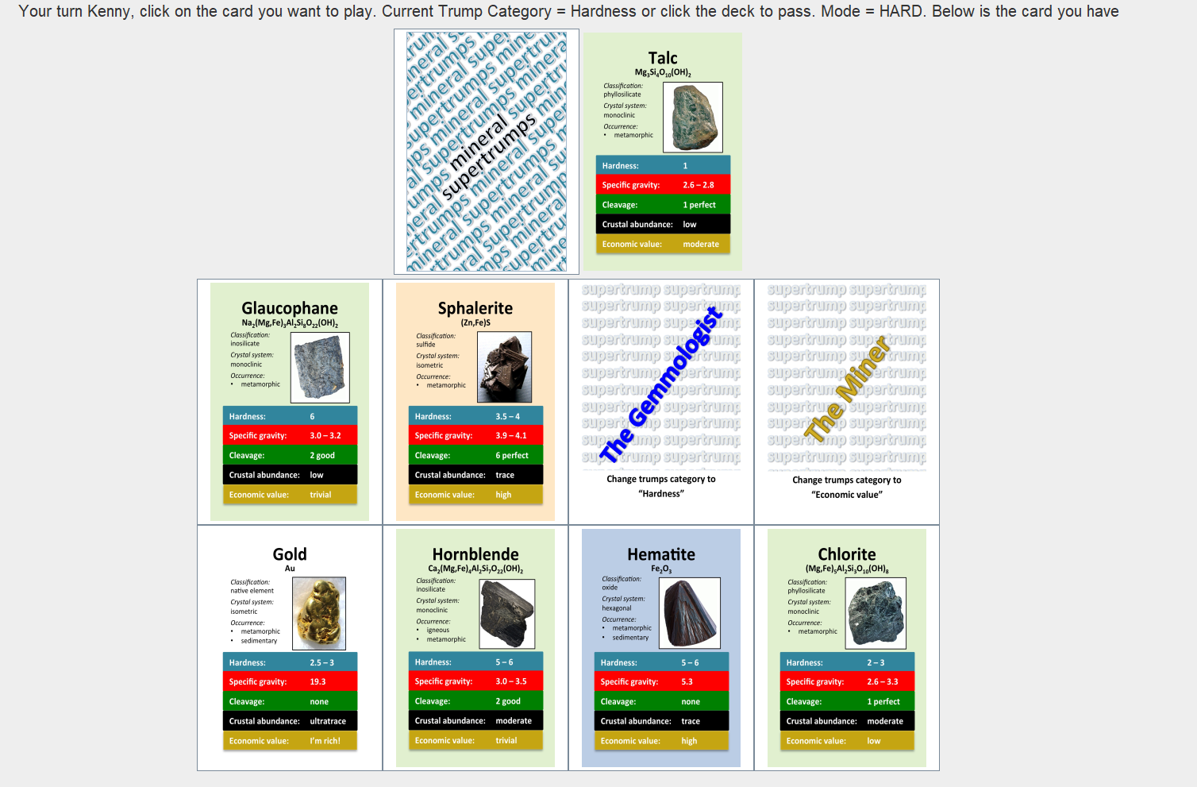

After picking the card, the game prompts into the next player.

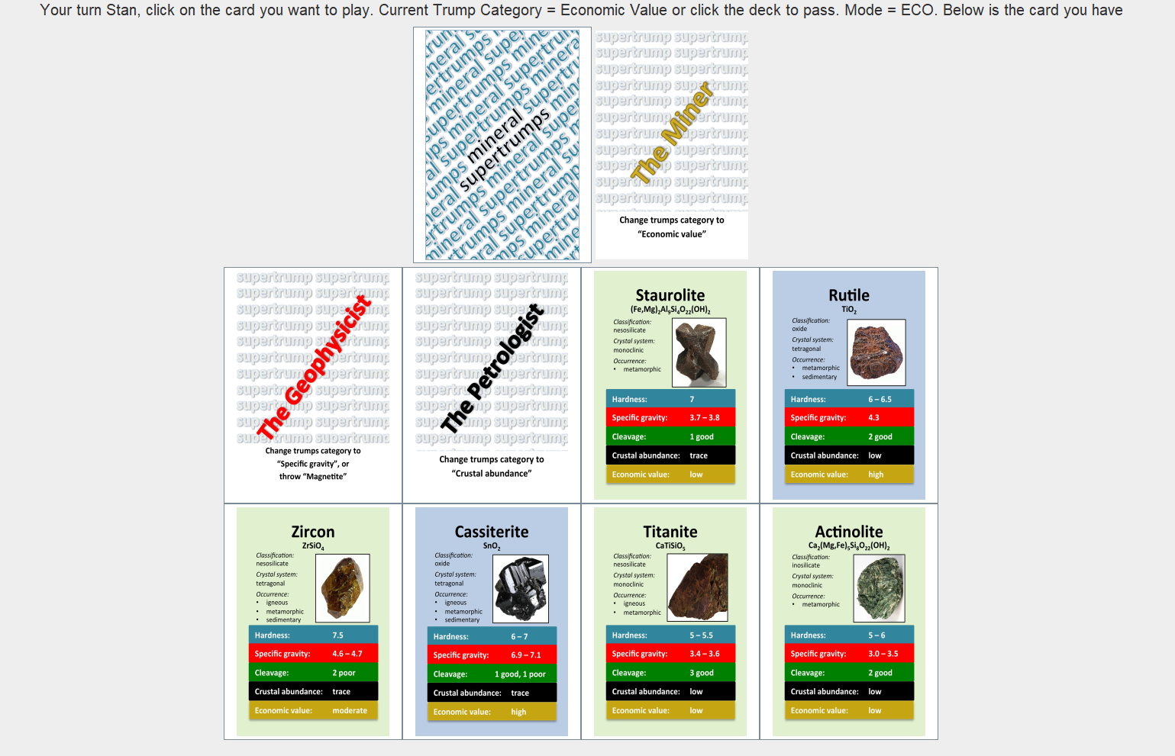

After the player chose one of the Supertrumps cards, the category changed based on the card effect.

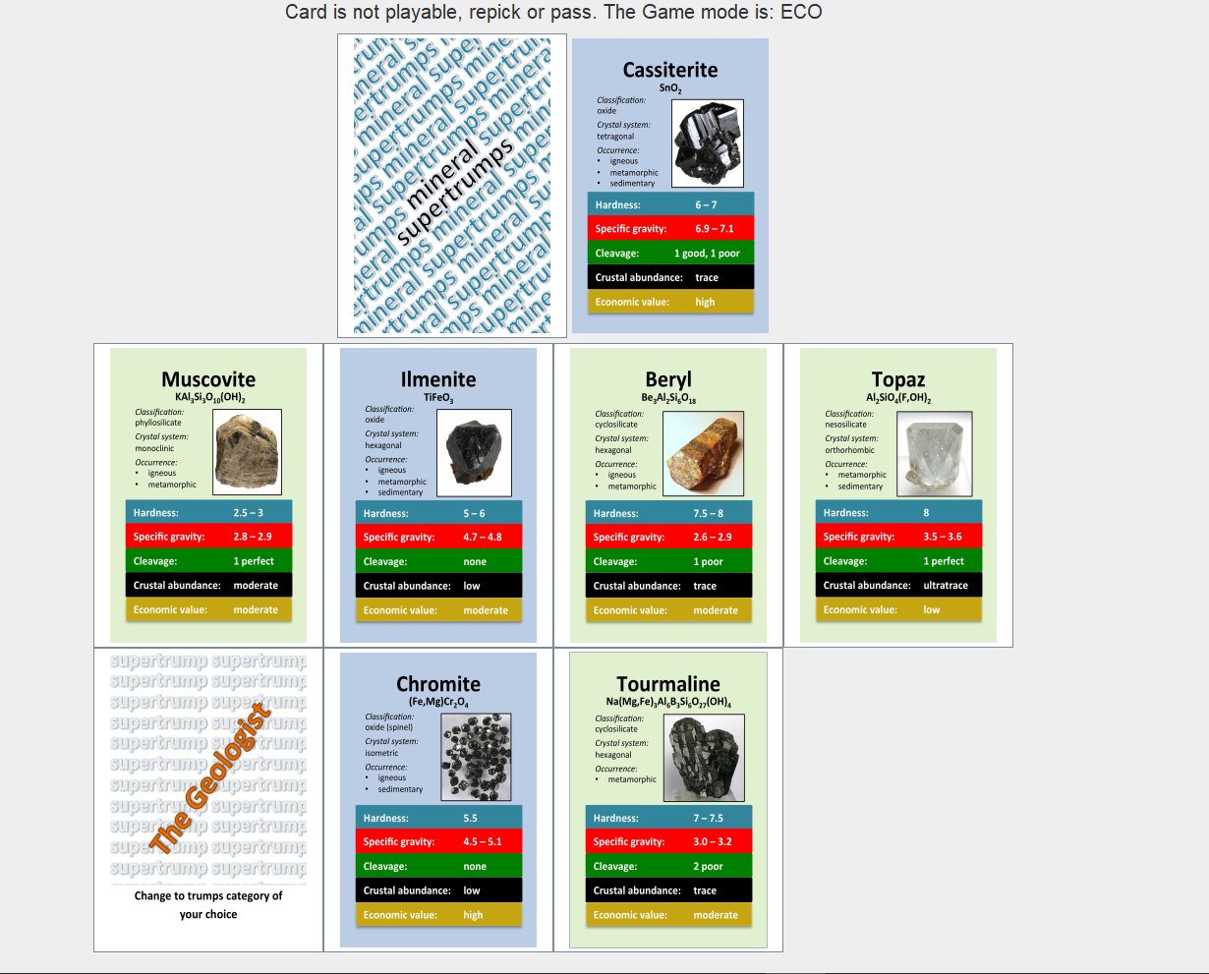

When the player tried to pick the card that is lower than the recent card value, there is a message that prohibit the player to pick the card unless they pick higher value than the card value or pass the turn.

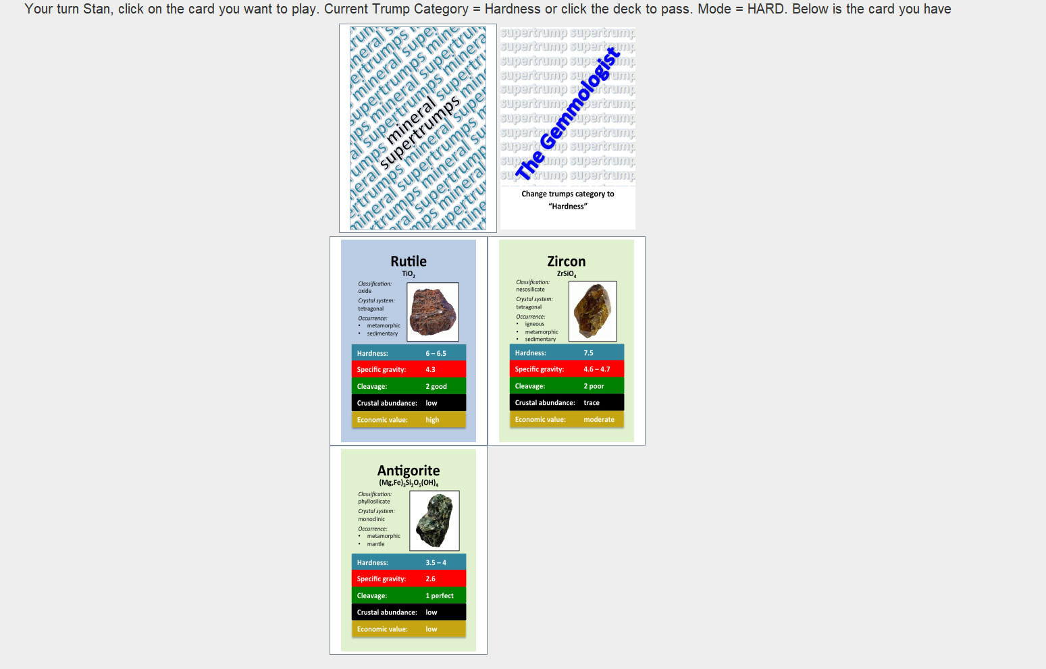

After a player left, the recent card on the recent player that is left from the game still keeps in there unless the other player plays a card to replace the recent card.

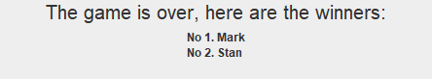

This is the end screen where there is only 1 player left, and the screen shows the winners of the game and not displayed the player left.

GitHub Repository

<https://github.com/hanseltertiusJCU/Assignment2CP2406>